***What drives crude oil prices: Supply Non-OPEC***

Oil production from countries outside the [Organization of the Petroleum Exporting Countries (OPEC)](https://www.eia.gov/tools/glossary/index.cfm?id=O#opec) currently represents about 60 percent of world oil production. Key centers of non-OPEC production include North America, regions of the former Soviet Union, and the North Sea.

**Around $75 for the remainder of this year, with low growth in non-OPEC supply (1.22 mill barr / day Q2, 0.9 Q3, 0.16 Q4) forecast. Supply will increase starting in 2025 (forecast).**

In contrast to OPEC oil production, which is subject to central coordination, non-OPEC producers make independent decisions about oil production. Also, in contrast to OPEC, where oil production is mostly in the hands of national oil companies (NOCs), international or investor-owned oil companies (IOCs) perform most of the production activities in non-OPEC countries. IOCs seek primarily to increase shareholder value and make investment decisions based on economic factors. While some NOCs operate in a similar manner as IOCs, many have additional objectives such as providing employment, infrastructure, or revenue that impact their country in a broader sense. As a result, non-OPEC investment, and thus future supply capability, tends to respond more readily to changes strictly in market conditions.

Producers in non-OPEC countries are generally regarded as price takers, that is, they respond to market prices rather than attempt to influence prices by managing production. As a result, non-OPEC producers tend to produce at or near full capacity and so have little spare capacity. Other things being equal, lower levels of non-OPEC supply tend to put upward pressure on prices by decreasing total global supply and increasing the "call on OPEC." The greater the call on OPEC, the greater is its likely ability to influence prices.

***GDP growth + small world production capacity growth, if not decline, put upward pressure on oil prices.***

***Just anticipation of supply (forecasts) also affects oil prices.***

World capacity = OPEC capacity + non-OPEC growth

Non-OPEC production occurs largely in areas that have relatively high finding and production costs, as most of the lower cost conventional oil resources are in OPEC member countries. Non-OPEC producers have therefore led the way into frontier areas such as the deepwater offshore, and pursued unconventional sources such as oil sands. As a result, non-OPEC production usually has a cost disadvantage compared to OPEC production.

Non-OPEC producers have often led in developing new production technology. While this has sometimes resulted in the development of higher-cost supplies, costs often fall as technology advances, which can ultimately put downward pressure on prices.

In addition to non-OPEC crude oil production, natural gas production provides additional supplies of liquids, called natural gas liquids (NGLs). Rising natural gas production in recent years has resulted in substantial increases in NGLs. This has contributed to total world liquids supply and helped to mitigate price increases.

While increases in non-OPEC supply contribute to lower oil prices, disruptions of non-OPEC production reduce global oil supply and can lead to higher oil prices. These unplanned outages can persist for long periods of time. The uncertainty about when the production will return to markets further adds to price volatility.

Estimated unplanned disruptions reflect the level of volumes shut-in, accounting for effective production capacity.

Oil prices are not only affected by actual non-OPEC production, but also by changes in expectations about future non-OPEC supply. From 2005 through 2008, final production reports for non-OPEC production were consistently lower than forecast expectations. This reduction in anticipated production forced the world to unexpectedly rely more heavily on OPEC crude, drawing down their levels of spare capacity. The downward revisions in expectations of non-OPEC production contributed to upward pressure on oil prices.

What drives crude oil prices: Supply OPEC

Crude oil production by the [Organization of the Petroleum Exporting Countries (OPEC)](https://www.eia.gov/tools/glossary/index.cfm?id=O#opec) is an important factor that affects oil prices. This organization seeks to actively manage oil production in its member countries by setting production targets. Historically, crude oil prices have seen increases in times when OPEC production targets are reduced.

OPEC member countries produce about 40 percent of the world's crude oil. Equally important to global prices, OPEC's oil exports represent about 60 percent of the total petroleum traded internationally. Because of this market share, OPEC's actions can, and do, influence international oil prices.In particular, indications of changes in crude oil production from Saudi Arabia, OPEC's largest producer, frequently affect oil prices.

The extent to which OPEC member countries utilize their available production capacity is often used as an indicator of the tightness of global oil markets, as well as an indicator of the extent to which OPEC is exerting upward influence on prices. EIA defines spare capacity as the volume of production that can be brought on within 30 days and sustained for at least 90 days. Saudi Arabia, the largest oil producer within OPEC and the world's largest oil exporter, historically has had the greatest spare capacity. Saudi Arabia has usually kept more than 1.5 - 2 million barrels per day of spare capacity on hand for market management.

OPEC spare capacity provides an indicator of the world oil market's ability to respond to potential crises that reduce oil supplies. As a result, oil prices tend to incorporate a rising risk premium when OPEC spare capacity reaches low levels. From 2003 through 2008, OPEC's total spare capacity remained near or below 2 million barrels per day (or less than 3 percent of global supply), which provided very little cushion for fluctuations in supply in a context of rapidly rising demand. Markets are influenced by geopolitical events within and between OPEC countries because they have, historically, resulted in reductions in oil production. Given OPEC's market significance, events that entail an actual or future potential loss of oil supplies can produce strong reactions in oil prices.

Low spare capacity limits OPEC's ability to respond to demand and price increases, while high spare capacity indicates a withholding of production presumably for price management purposes.

Despite OPEC's efforts to manage production and maintain targeted price levels, member countries do not always comply with the production targets adopted by the organization. Oil prices can be affected by member countries' unwillingness to maintain production targets. In addition, unexpected outages can reduce OPEC production. The amount of the disruption, how quickly it occurs, and the uncertainty of restoring the output have considerable influence on oil prices.

Natural gas liquids (NGLs) are not included in OPEC production allocations and can provide substantial additional volumes to world liquids supply.

The behavior of oil prices depends not only on current supply and demand, but also on projected future supply and demand. OPEC adjusts member countries' production targets based on current and expectations of future supply and demand. Estimating future supply and demand, however, is especially challenging when market conditions are uncertain and are changing rapidly. There can also be significant lags in OPEC production target adjustments in response to market conditions, which also can impact prices.

What drives crude oil prices: Balance

Inventories act as the balancing point between supply and demand. During periods when production exceeds consumption, crude oil and petroleum products can be stored for expected future use. In the economic downturn of late 2008 and early 2009, for example, the unexpected drop in world demand led to record crude oil inventories in the United States and other OECD countries. In contrast, when consumption outstrips current production, supplies can be supplemented by draws on inventories to satisfy the needs of consumers. Given the uncertainty of supply and demand, petroleum inventories are often seen as a precautionary measure.

Refineries and storage terminals can store crude oil and/or finished products like motor gasoline, heating oil, and diesel to prepare for seasonal fluctuations, refinery maintenance, or unexpected weather. Some petroleum products, such as heating oil and gasoline, have pronounced seasonal demand variance; inventories rise when consumption is lower and are drawn down when consumption increases. For this reason, inventory levels are most usefully assessed in relation to prior year levels for the same calendar quarter.

Because inventories can satisfy either current or future demand, their level is sensitive to the relationship between the current price of oil and expectations of future prices. If market expectations indicate a change toward relatively stronger future demand or lower future supply, prices for futures contracts will tend to increase, encouraging inventory builds to satisfy the otherwise tightening future balance. On the other hand, a sharp loss of current production or unexpected increase in current consumption will tend to push up spot prices relative to futures prices and encourage inventory draw downs to meet the current demand.

The relationship between prices and inventories allows for effects in either direction. If futures prices rise relative to the current spot level, incentives to store oil (and wait to sell at the higher expected price) will strengthen. Conversely, if market participants notice an increase in crude oil storage, this increase can indicate that current production surpasses current consumption at the prevailing price. Spot prices will likely drop to rebalance demand and supply. This balancing between current and future prices and between supply and demand through inventories is one of the main connections between financial market participants and commercial companies with a physical interest in oil, both of whom engage in futures trading. Physical inventory levels and price spreads over time act as a signals between current market participants and those with longer-term exposures.

The U.S. Energy Information Administration publishes weekly, monthly, and annual inventory statistics for crude oil and its related products. Industrialized countries that belong to the Organization of Economic Cooperation and Development (OECD) countries usually publish inventory statistics on a regular basis. However, inventory data for other countries—including key developing countries with rapidly growing oil consumption as well as major producing countries—is sometimes available on a less timely basis, or in some cases, not available at all. In addition, oil is often stored on ships at sea. The lack of complete information on inventories creates additional uncertainty in oil markets, which can also influence oil prices.

Finally, in addition to the commercial inventories discussed above, the United States and other countries maintain strategic reserves of oil. The U.S. Strategic Petroleum Reserve, which is maintained by the Department of Energy, holds oil that can be drawn upon by order of the President in the event of a supply disruption that meets specific statutory criteria. Members of the International Energy Agency, including the United States, collectively hold about 1.6 billion barrels of publically-owned petroleum stocks for emergency response.

What drives crude oil prices: Spot Prices

Crude oil is traded in a global market. Prices of the many crude oil streams produced globally tend to move closely together, although there are persistent differentials between light-weight, low-sulfur (light-sweet) grades and heavier, higher-sulfur (heavy-sour) crudes that are lower in quality.

Many types of crude oil are produced around the world. Variations in quality and location result in price differentials, but because oil markets are integrated globally, prices tend to move together.

Mars Blend refers to a type of crude oil blend sourced from the Gulf of Mexico, specifically from the Mars oilfield.

Basically, you have location, density, and sulfur content (+maybe export destination look Iran) that determine the type of oil we deal with. WTI crude is the benchmark for the US, but there are loads of other crude oils that have different prices, like WTI Midlands, West Texas Sour, Arkansas sweet.

And the same stuff applies to other countries outside the US. For example, UAE as Das, Umm Lulu, Upper Zakum, Murban crude but the benchmark is Dubai. Saudi Arabia has Arab Extra Light, Arab Light, Arab Heavy, Arab Medium.

And again that prices you see are the near month future prices NOT the spot. The spot is not a contract is the live price it is a transaction you pay and as soon as the payment is complete oil is heading your way.

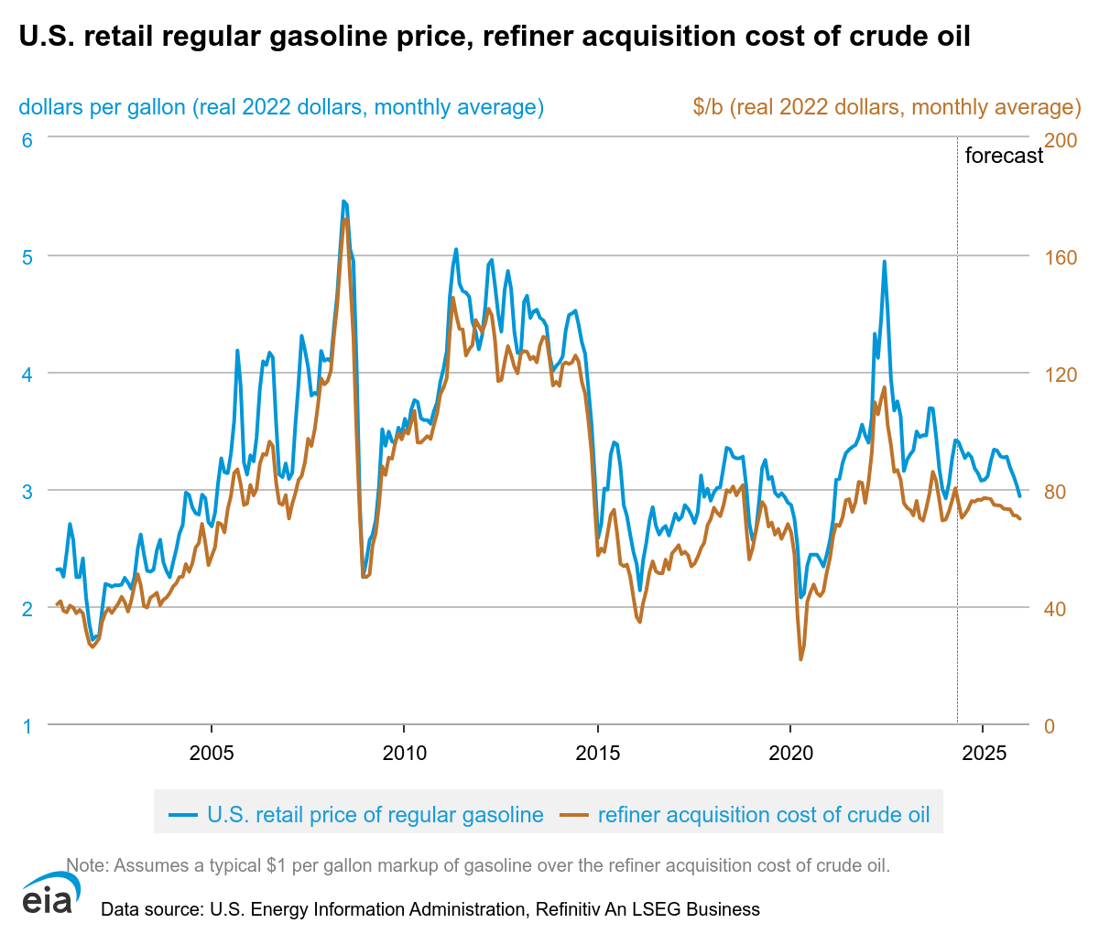

Both crude oil and petroleum product prices can be affected by events that have the potential to disrupt the flow of oil and products to market, including geopolitical and weather-related developments. These types of events may lead to actual disruptions or create uncertainty about future supply or demand, which can lead to higher volatility in prices. The volatility of oil prices is inherently tied to the low responsiveness or "inelasticity" of both supply and demand to price changes in the short run. Both oil production capacity and the equipment that use petroleum products as their main source of energy are relatively fixed in the near-term. It takes years to develop new supply sources or vary production, and it is very hard for consumers to switch to other fuels or increase fuel efficiency in the near- term when prices rise. Under such conditions, a large price change can be necessary to re-balance physical supply and demand following a shock to the system. (demand or supply changes as a result of an event but then the price change needed to come back to equilibrium is very high due to inelasticity) So supply decreases for political reasons the price shoots up but it must go very high up for the demand to decrease soas to get back to equilibrium because of inelasticity. For the pandemic is was the oil demand that decreased initially so the event dictates which one is first affected.It’s mainly the supply that is first affected cause most events are of political nature.

Much of the world's crude oil is located in regions that have been prone historically to political upheaval, or have had their oil production disrupted due to political events. Several major oil price shocks have occurred at the same time as supply disruptions triggered by political events, most notably the Arab Oil Embargo in 1973-74, the Iranian revolution and Iran-Iraq war in the late 1970s and early 1980s, and Persian Gulf War in 1990. More recently, disruptions to supply (or curbs on potential development of resources) from political events have been seen in Nigeria, Venezuela, Iraq, Iran, and Libya.

Given the past history of oil supply disruptions emanating from political events, market participants are always assessing the possibility of future disruptions and their potential impacts. In addition to the size and duration of a potential disruption, they also consider the availability of crude stocks and the ability of other producers to offset a potential supply loss. For example, if the market has ample spare production capacity to offset a possible disruption, its likely impact on prices would be smaller than if spare production capacity was much lower. When there are significant concerns about the potential for a disruption at a time when spare capacity and inventories are not seen as sufficient to substantially offset the associated loss in supply, prices may be above the level that might be expected if only current demand and supply were considered, as forward-looking behavior adds a "risk premium."

Weather can also play a significant role in oil supply. Hurricanes in 2005, for example, shut down oil and natural gas production as well as refineries. As a result, petroleum product prices increased sharply as supplies to the market dropped. Severely cold weather can strain product markets as producers attempt to supply enough of the product, such as heating oil, to consumers in a short amount of time, resulting in higher prices. Other events such as refinery outages or pipeline problems can restrict the flow of oil and products, driving up prices.

However, the influence of these types of factors on oil prices tends to be relatively short lived. Once the problem subsides and oil and product flows return to normal, prices usually return to previous levels.

What drives crude oil prices: Financial Markets

Market participants not only buy and sell physical quantities of oil, but also trade contracts for the future delivery of oil and other energy derivatives. One of the roles of futures markets is price discovery, and as such, these markets play a role in influencing oil prices.

Oil market trading activity involves a range of participants with varying motivations, even within individual participants. Some, such as oil producers and airlines, have a significant commercial exposure to changes in the price of oil and petroleum-based fuels, and may seek to hedge their risk by buying and selling energy derivatives. For example, an airline may want to buy futures or options in order to avoid the possibility that its future fuel costs will rise above a certain level, while an oil producer may want to sell futures in order to lock in a price for its future output.

Banks, hedge funds, commodity trading advisors, and other money managers-who often do not have interests in trading physical oil-are also active in the market for energy derivatives to try to profit from changes in prices. In recent years, investors have also shown interest in adding energy and other commodities as alternatives to equity and bond investments to diversify their portfolios or to hedge inflation risks. Every transaction must involve both a buyer and a seller, and the desired "long" buyer and "short" seller positions of those with direct commercial interests in the oil market do not necessarily equal one another. Banks, hedge funds, and other "non-commercial" investors can add liquidity to futures and derivative markets by taking the other side of transactions with commercial participants. On the other hand, concerns have been raised that non-commercial commodity trading and investment may "use up" liquidity and amplify price movements, particularly at times when momentum is running strongly in a particular direction.

Activity in commodity exchange contracts has risen in recent years. One measure of activity in futures markets is open interest on exchanges, which indicates the number of contracts in a trading session (daily/quarterly…) that have not been settled or closed. Open interest on exchange-traded crude oil futures contracts increased substantially over the past decade, as measured by the New York Mercantile Exchange (NYMEX), the main commodities exchange for energy products in the United States. Both commercial participants (those that have a direct interest in physical oil production, consumption, or trade) and non-commercial investors (money managers and funds that are interested in trading contracts for investment and diversification purposes) have shown increased trading activity. Care must be taken in interpreting these data, however, because the vast majority of positions are held in the less transparent over-the-counter (OTC) market rather than on exchanges. In addition to futures contracts, another way for market participants to invest in crude oil is through the buying and selling of options contracts. Options allow for investment exposure with limited potential for losses and provide an insurance-like instrument against adverse commodity price movements.

The Commodity Futures Trading Commission publishes a weekly activity report on oil trading that occurs on exchanges (e.g., NYMEX), the Commitment of Traders Report. In this report, the activities of multiple trading categories are detailed, including physical participants (producers, merchants, processors, and end users), money managers (usually hedge funds or other sophisticated traders), and swap dealers (traditionally investment banks or commodity broker/dealers). On a net basis (subtracting short positions from long positions), physical participants tend to be net short while traders in the money managers category tend to be net long.

They are now net long, and most often, they are net short so this means they believe the price will go up. I have looked over the time series and it is a pretty good long term indicator. So basically the net position of producers, merchants, processors and end users.

Here, it is very event-driven. OBV is they accumulate long positions, then the sentiment is long.

So look at the net position of money managers + physical participants (producers, merchants, processors, and end users.)

During the world financial crisis that occurred in the latter half of 2008 and 2009, markets saw a dramatic increase in the correlation between crude oil and other commodities as demand decreased for raw materials. However, both before and after the world economic slowdown, there were observable increases in the correlations between commodity prices. At the same time as this rise in correlations was a rise in interest in general commodity exposure. A growing number of investors have gained exposure to commodities by investing in index funds-market instruments that provide exposure to baskets of commodities. These index funds usually establish shares of various energy and other commodities to provide diversity across a range of commodities. Also, exchange traded funds (ETFs)-which can be bought and sold throughout the day like individual common stocks-are an increasingly popular means for investors, including individuals, to gain exposure to commodities as an asset class.

Correlation is not the same as causation, however, and the relationship between crude oil and other financial markets is complex. Even with observed movements in correlation levels, influences between crude oil price changes and changes in values of other asset classes are unclear. For example, it is possible that high correlations are due to more primary relationships with a third common factor, such as economic growth expectations. Another complicating factor is that these relationships and their strength vary over time. Analysts continue to work to better understand the connections between these markets.

Most index funds are "long only" funds whose value will increase only when the prices of the underlying commodities rise. Investors in such instruments expect commodity prices to rise; money is lost if the values of the underlying commodities in the index decrease. Many of the managers of index-style investments do not trade the individual components of an index on a daily basis; instead, they buy and hold these investments over periods of months or years, rolling contracts forward to avoid physical delivery.

Some market observers believe that increased trading activity by investors and long-only index funds in oil markets has had a significant impact on the energy price formation process. Although a growing body of research by academics and securities market analysts examines this issue, no definitive conclusion either proving or disproving a causal linkage between non-commercial trading and large energy price swings over the past few years has been reached.

Because the vast majority of positions are held in the less transparent OTC derivatives market, however, analysis that relies only on readily available data from the transparent portion of the market may offer only limited insights. Additional data and analysis are needed to better understand the relationship between energy derivatives trading and price movements. In addition, the global nature of trade in energy-related derivatives adds to the challenges of analyzing trading activity.

**OTHER FINANCIAL MARKETS**

Prior to 2007, stocks, bonds, and exchange rates showed only infrequent, fleeting correlations to oil futures prices. In contrast, the price of crude oil showed positive correlations with stocks from 2008-2010, negative correlations with the value of the U.S. dollar during most of late-2007 to the present, and more irregular but often negative correlations with bond prices during 2008-2010.

For each asset class, there are financial, physical, and common underlying economic factors-such as the economic downturn and recovery-that could be influencing these more significant correlations. Financial factors include developments such as the growing interest over the last decade in crude oil as an investment asset. This investment interest has altered the financial money flow into and out of commodities. Physical crude oil markets can also be influenced by outside factors. Exchange rates and economic factors play a role in crude oil production and consumption, possibly leading to price correlations.

A second potential reason is that U.S. dollar depreciation will decrease the effective profits of non-U.S. producers, when converted into foreign currencies. To counteract this, these countries may target higher dollar prices of oil to maintain real revenue,

What drives crude oil prices: Demand OECD

The Organization of Economic Cooperation and Development (OECD) consists of the United States, much of Europe, and other industrialized countries. At 46 percent of world oil consumption in 2021, these large economies consume less oil than the non-OECD countries, and have low or declining oil consumption growth. Oil consumption in the OECD countries peaked in 2005, whereas non-OECD consumption rose more than 50 percent since then.

Structural conditions in each country's economy influence the relationships among oil prices, economic growth, and oil consumption. Developed countries tend to have higher vehicle ownership per capita. Because of this, oil use within the OECD transportation sector usually accounts for a larger share of total oil consumption than in non-OECD countries; it is also more mature and slower-growing. Economic conditions and policies that affect the transport of goods and people thus have a significant impact on total oil consumption in OECD countries. Many OECD countries have higher fuel taxes and policies to improve the fuel economy of new vehicles and increase the use of biofuels. This tends to slow the growth in oil consumption even in times of strong economic growth. Furthermore, the economies in OECD countries tend to have larger service sectors relative to manufacturing. As a result, strong economic growth in these countries may not have the same impact on oil consumption as it would in non-OECD countries.

OECD countries tend to have fewer subsidies on end-use prices, so changes in market oil prices are often quickly reflected in prices faced by consumers. However, it takes time for people to adjust their transportation routines and for the vehicle stock to turn over and become more energy-efficient in response to price changes.

Changes in expected future oil prices also affect consumers' decisions concerning modes of transportation and vehicle purchases. If prices are expected to remain high or increase in the future, more consumers may decide to purchase more fuel efficient vehicles or use public transportation. Decisions like these help to reduce future oil demand and would tend to moderate expected price increases.

What drives crude oil prices: Demand Non-OECD

Oil consumption in developing countries that are not part of the [Organization of Economic Cooperation and Development (OECD)](https://www.eia.gov/tools/glossary/index.cfm?id=O#org_econ_cd) has risen sharply in recent years. While oil consumption in the OECD countries declined between 2000 and 2010, non-OECD oil consumption increased more than 40 percent. China, India, Saudi Arabia, Indonesia, Brasil had the largest growth in oil consumption among the countries in the non-OECD during this period.

strong relationship between GDP growth rates and growth in oil consumption in non-OECD countries.

Kinda same in OECD

Rising oil consumption reflects rapid economic growth in these countries. Current and expected levels of economic growth heavily influence global oil demand and oil prices. Commercial and personal transportation activities, in particular, require large amounts of oil and are directly tied to economic conditions. Many manufacturing processes consume oil as fuel or use it as feedstock, and in some non-OECD countries, oil remains an important fuel for power generation. Because of these uses, oil prices tend to rise when economic activity and in turn oil demand is growing strongly. Many non-OECD countries are also experiencing rapid growth in population, which is an additional factor supporting strong oil consumption growth.

Structural conditions in each country's economy further influence the relationship between oil prices and economic growth. Developing countries tend to have a greater proportion of their economies in manufacturing industries, which are more energy intensive than service industries. Although transportation oil use is usually a smaller share of total oil consumption in non-OECD countries, this use tends to increase rapidly as expanding economies increase the need to move goods and people. Vehicle ownership per capita is also highly correlated with rising incomes and has much room to grow in non-OECD countries. For these reasons, non-OECD economic growth rates tend to be an important factor affecting oil prices. China's strong economic growth has recently resulted in that country becoming the largest energy consumer and second largest oil consumer in the world. In addition, China's rising oil consumption has been a major contributor to incremental growth in worldwide oil consumption. EIA projects that virtually all the net increase in oil consumption in the next 25 years will come from non-OECD countries.

Although oil use is clearly tied to economic activity, energy policies also significantly affect that relationship. Many developing countries, for example, control or subsidize end-use prices, which inhibits consumer response to market price changes. This reduced demand response to price changes further contributes to the importance of economic growth as a key driver of non-OECD demand and in turn global oil prices.

While current oil consumption is primarily related to current economic activity, changes in the outlook for future economic conditions can also have an immediate impact on oil prices. For example, an improvement in the economic outlook would tend to increase the chance that oil markets will tighten in the future, resulting in higher expected future oil prices. This change in expectations would be reflected in higher oil futures prices. This rise in futures prices increases the incentive to hold inventories, which in turn decreases available current supply and tends to raise current prices.

